Name: Quang Huynh



**Blood Typing Practice**

**Blood Types**

There are many different ways to classify blood types, but the most common blood type classification system is the **ABO** system. There are four blood types in the ABO system: **Type A, Type B, Type AB, and Type O**. Our blood types refer to different versions of proteins (aka- **antigens**) which are present on the surface of red blood cells. Another factor known as the **Rh factor** is a protein that is either present or absent, and gives us a + or – attached to our blood group to denote its presence or absence.

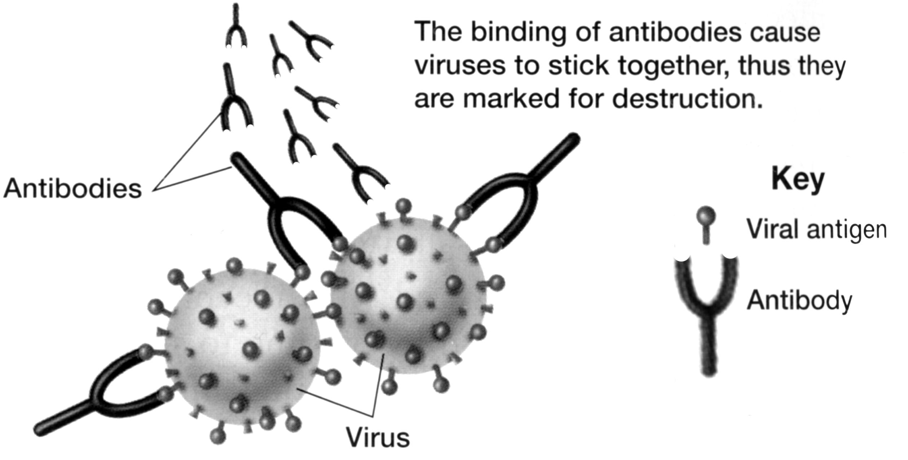

The Type A and Type B proteins are called **antigens,** or sometimes **agglutinogens,** because they can stimulate the body to produce an immune response. Antigens are substances that the body does not recognize as belonging to the “self” and that therefore trigger a defensive response from the **leukocytes** of the immune system **Antibodies**, sometimes called **agglutinins,** are special proteins that travel in the blood and help our bodies to destroy viruses or bacteria that may have infected our bodies or other substances seen as “foreign.”

**Questions:**

1. On the surface of erythrocytes are the **antigens** - glycoproteins necessary for cellular recognition. The combination of these cellular ID cards determines your blood type.

2. The “recognizers” of these cellular ID cards are called **antibodies.** They are located in the blood’s formed elements, specifically the buffy coat, and will act against any foreign antigens not located on your own blood cells.

3.

|  |  |
| --- | --- |
| image006 | **Blood group A**  If you belong to the blood group A, you have A antigens on the surface of your red blood cells and B antibodies in your blood. |
| image008 | **Blood group B**  If you belong to the blood group B, you have B antigens on the surface of your red blood cells and A antibodies in your blood. |
| image010 | **Blood group AB**  If you belong to the blood group AB, you have both A and B antigens on the surface of your red blood cells and no anti-A or anti-B antibodies in your blood. |
| image012 | **Blood group O**  If you belong to the blood group O, you have no A nor B antigens on the surface of your red blood cells, but you have both A and B antibodies in your blood. |

4. Correctly complete the following table:

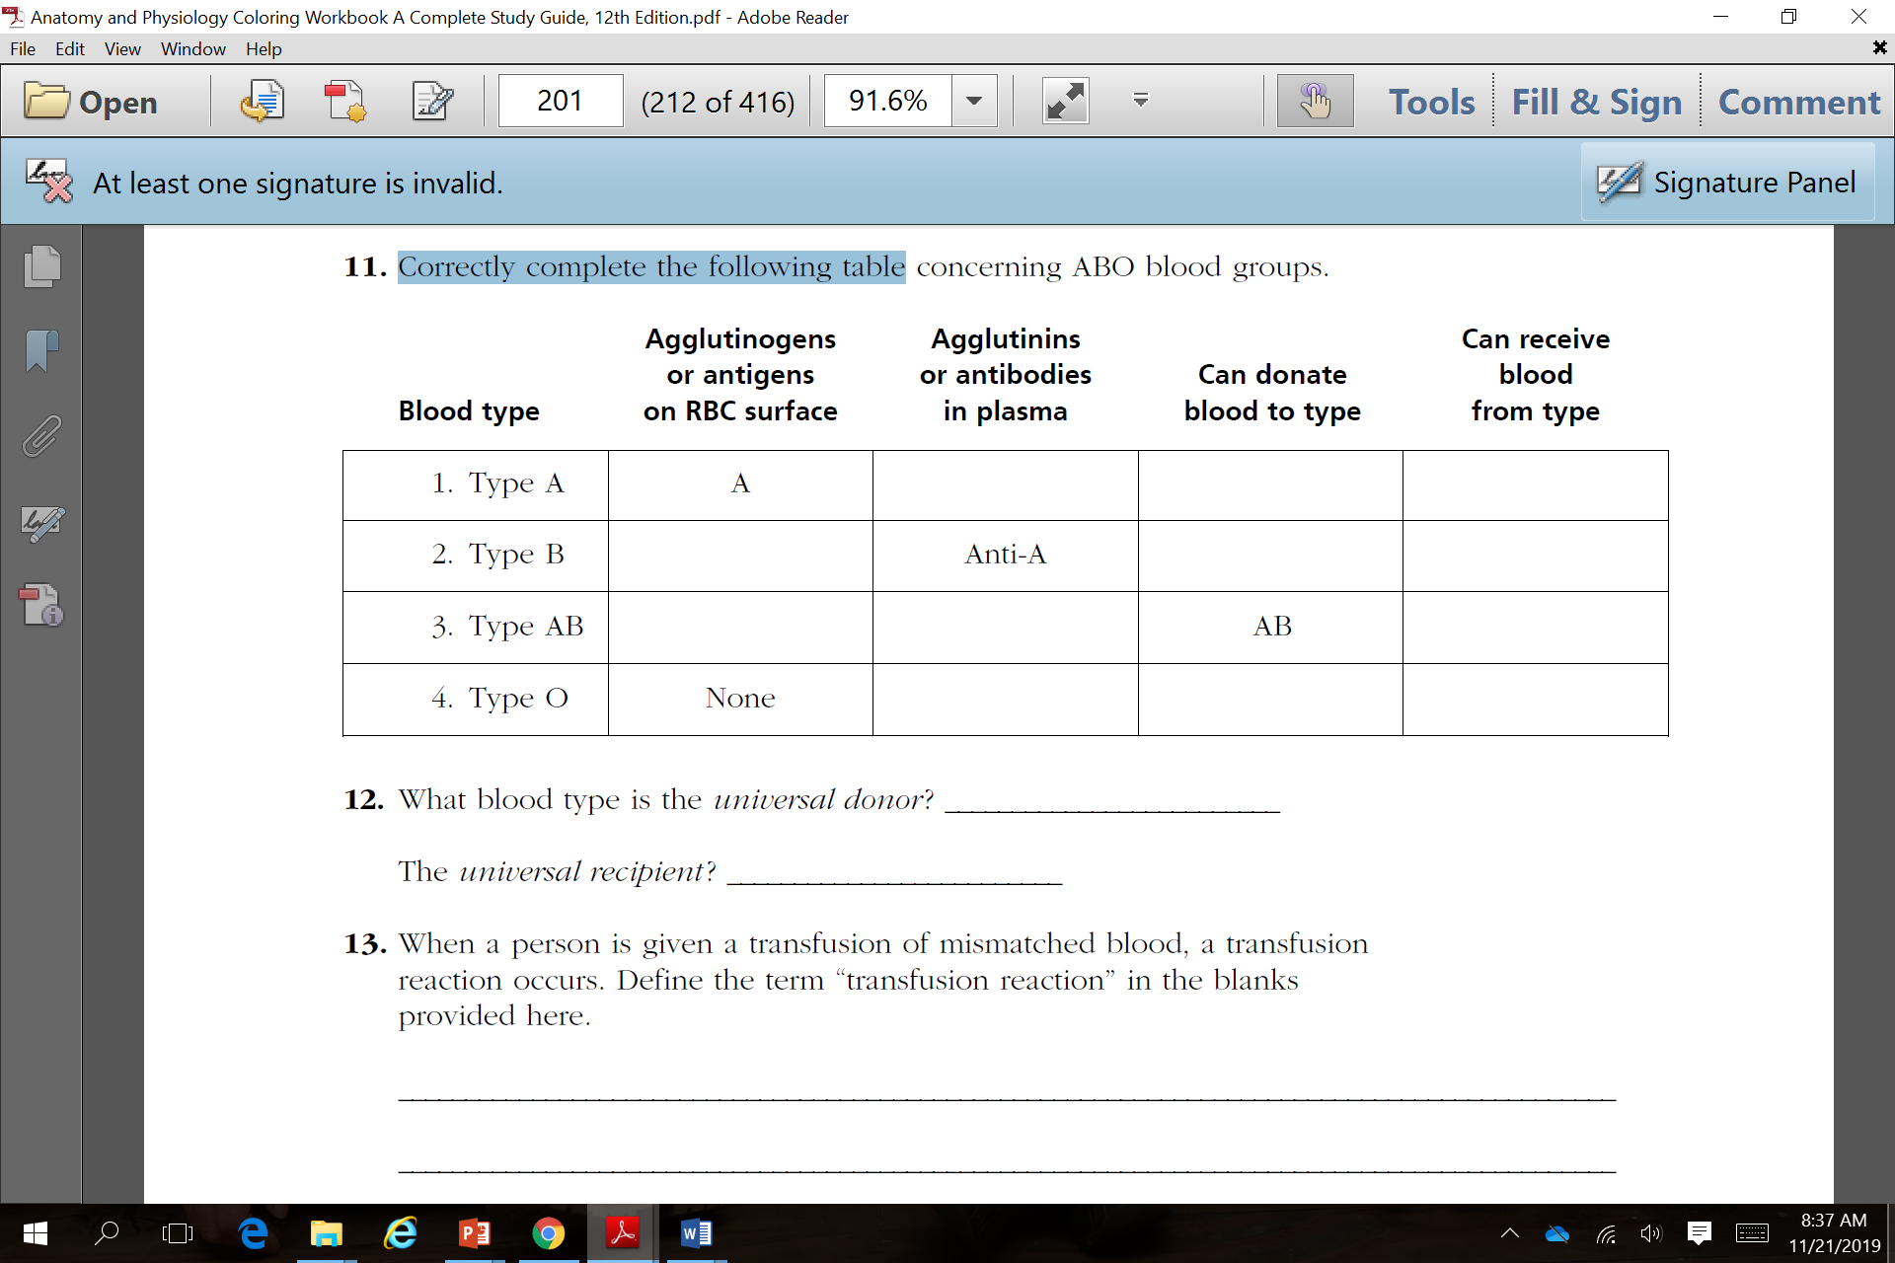

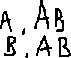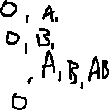

5. What blood type is the *universal donor*? O Explain why that is. Type O blood is the universal donor because it does not have any antigens. Type O contains both A and B antibodies.

6. The *universal recipient*? AB Explain why that is. Blood Type AB has no antibodies in the plasma. Also, it has both A and B antigens in the red blood cell. This means it could receive any blood type and be compatible.

**Challenge**

7. Identify the blood type of each sample given the test results.

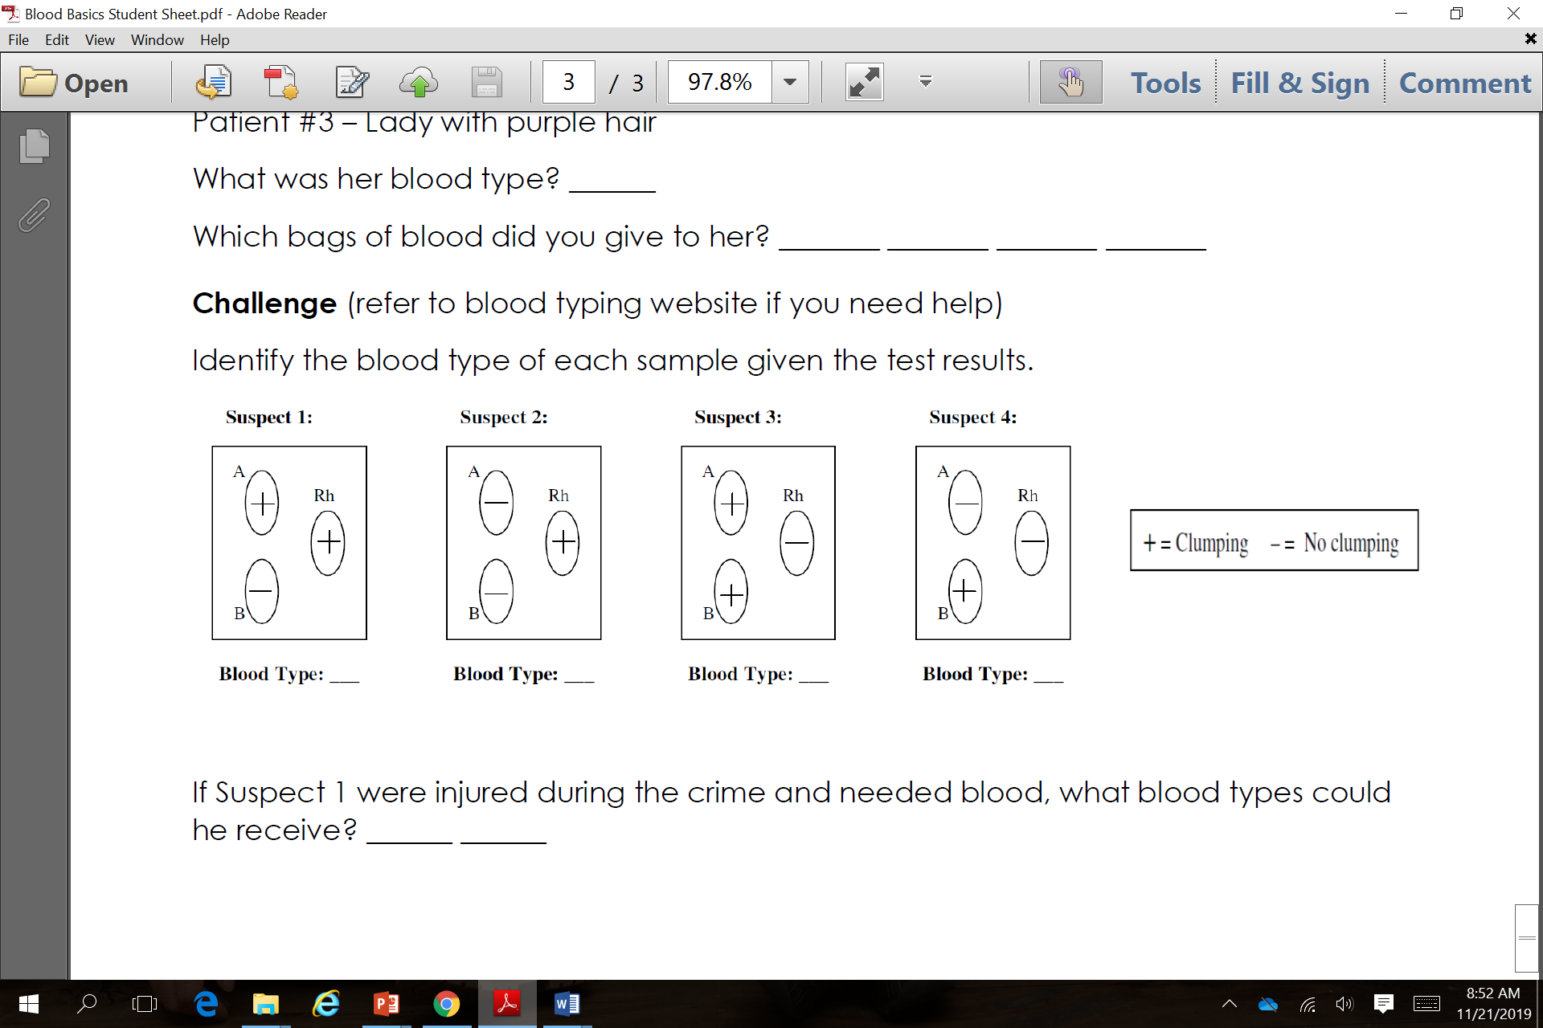 Donor #1 Donor #2 Donor #3 Donor #4



8. If Donor 1 were injured in an accident and needed blood, what blood types could

he receive? Donor 2,

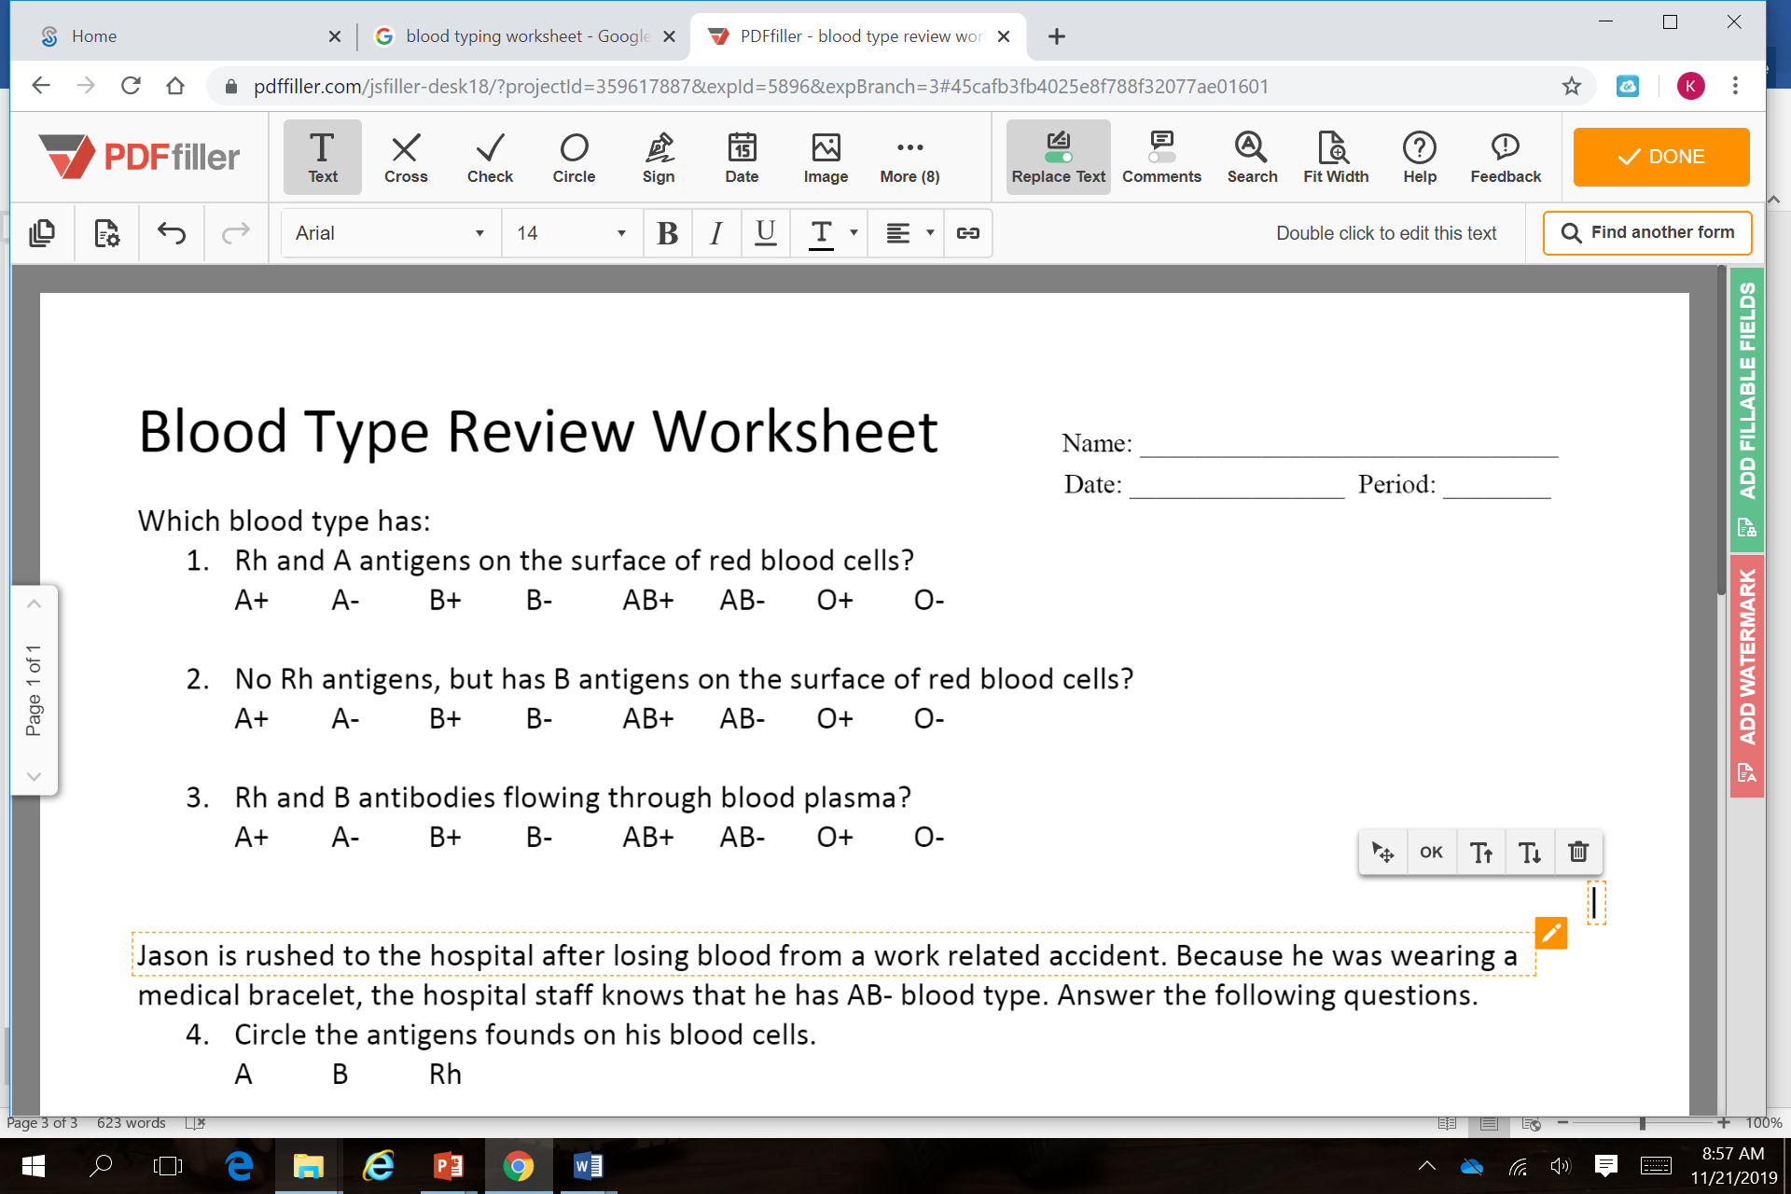9.



10. Your lab results showed the following agglutination patterns. Identify what blood types are shown below:



**Anti-Rh**